Scientific Revolution Concept Cards
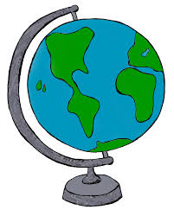Scientific Revolution Concept Cards

- Geocentric
- Scientific Revolution
- Heliocentric
- Ellipses
- Gravity
- Elements
- Rationalism
- Scientific method
- Age of Enlightenment
- Absolutism
- Glorious Revolution
- Constitutional monarchy
- Social contract
- Separation of powers
- Voltaire
- Diderot
- Mary Wollstonecraft
- Rousseau
- The Sun King
- Locke
- Montesquieu

- Geocentric
- Scientific Revolution
- Heliocentric
- Ellipses
- Gravity
- Elements
- Rationalism
- Scientific method
- Age of Enlightenment
- Absolutism
- Glorious Revolution
- Constitutional monarchy
- Social contract
- Separation of powers
- Voltaire
- Diderot
- Mary Wollstonecraft
- Rousseau
- The Sun King
- Locke
- Montesquieu

